As our team aims to find the best location of EV charging station, after researching several articles, I identify EV charging station density is a feature related to EV charging station location. Furthermore, I consider population and EV sales as 2 factors which have influence on EV charging station density. Hence, I collect Australian EV sales dataset, Australian EV charging station dataset and Australian population dataset to explore their relationship and build models to forecast the trend in next decade.

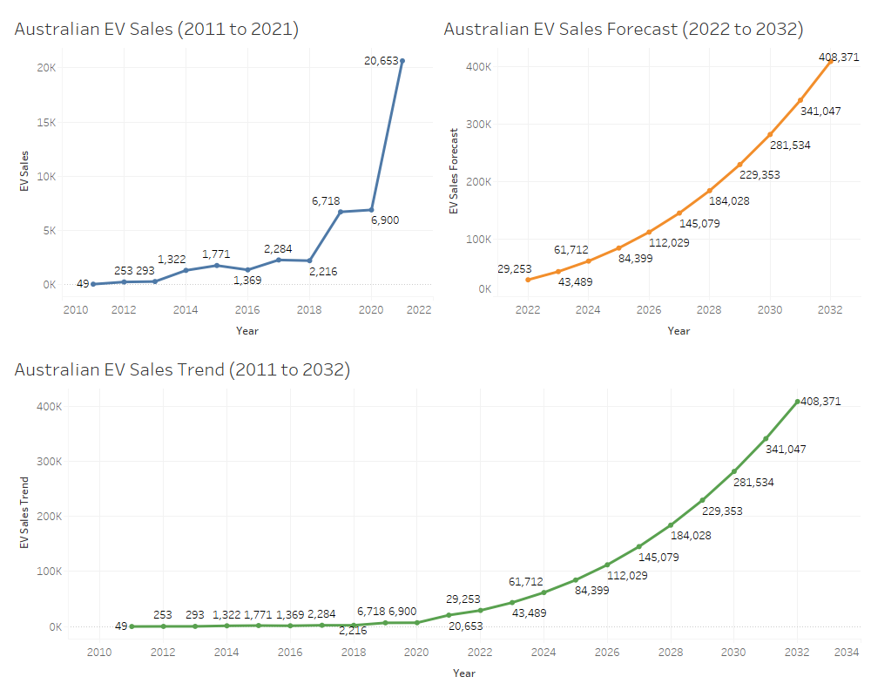

According to the figures above, from 2011 to 2021, Australian annual EV sales have increased rapidly from 49 to 20653. The model predicts that Australian annual EV sales will increase to 408, 371 in 2033.

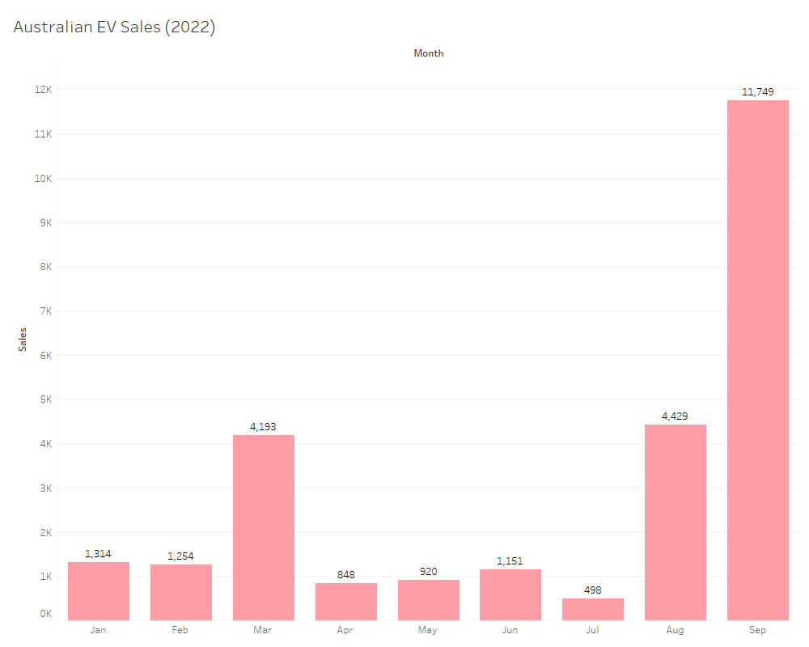

From Jan to Sep 2022, the total EV sales have achieved 26,356.

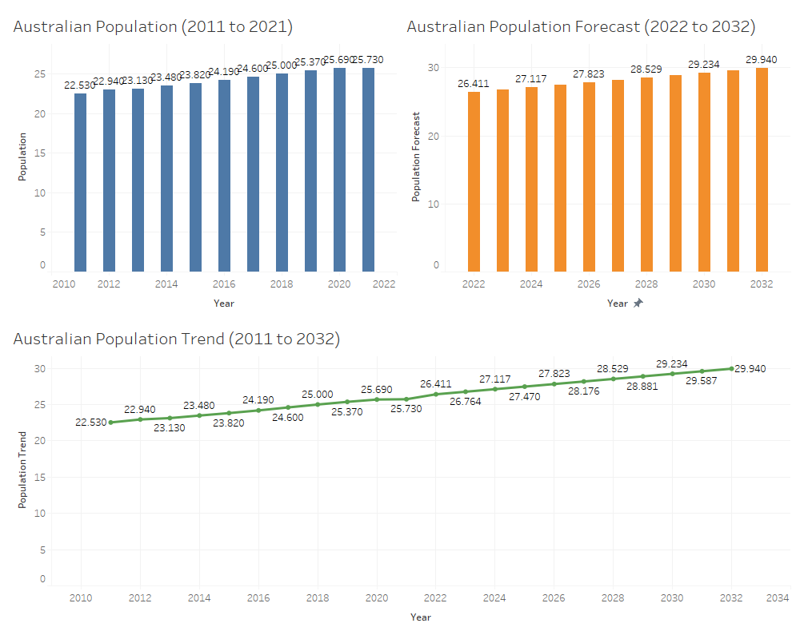

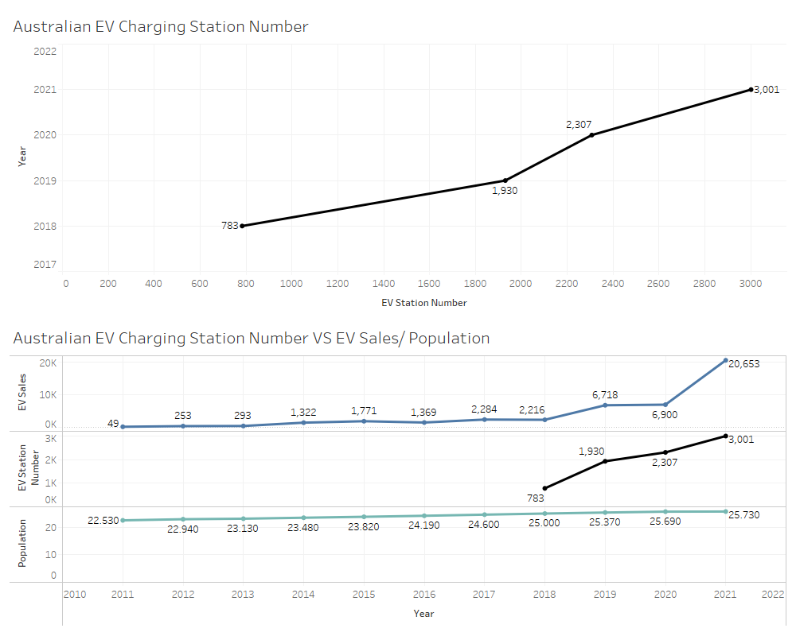Based on the above figures, it seems that EV sales and population have positive effect on EV station number. I plan to add more features to analyse EV charging station location in next trimester. Those features may include: road miles, distance after per charging, electric fees etc.